

CCP REPORT

GROUP MEMBERS:
- MISHAL KHALID CT-25156
- DIYA RANI CT-25165
COURSE INSTRUCTOR: SIR ABDULLAH
COURSE TITLE: PROGRAMMING FUNDAMENTALS
COURSE CODE: CT-175
DISCIPLINE: BCIT
INSTITUTION: NED UNIVERSITY OF ENGINEERING &TECHNOLOGY
Index

- PROJECT TITLE
- ABSTRACT
- INTRODUCTION
- OBJECTIVES
- TOOLS AND TECHNOLOGIES
- METHODOLOGY
- EXPECTED OUTCOMES
- PSEUDOCODE
- FLOWCHART
10. SOURCE CODE
11. TECHNICAL TERMS AND CONCEPTS
12. CONCLUSION
13. EXAMPLE RUNS

PROJECT TITLE: THE HANGMAN GAME
ABSTRACT
This project presents the design and development of a Hangman Game in C. The main goal of this program is to apply logic building and string manipulation through an interactive guessing game. The system architecture emphasizes code organization through the use of user-defined functions, efficient string manipulation, and dynamic control structures that manage the flow of gameplay. The game selects a random food item from a predefined list and challenges the player to guess the word letter by letter within a limited number of chances. The implementation makes use of arrays, loops, conditional statements, and functions to manage game flow and display progress to the player. Text-based visual feedback enhances user engagement, while modular design and standard libraries demonstrate fundamental programming skills. Overall, the project showcases how logic-driven design and creative programming can turn a traditional word-guessing game into a challenging, engaging and intelligent digital experience.
INTRODUCTION
The Hangman Game project is a console-based interactive word-guessing system developed in the C programming language. It has been designed to integrate multiple programming concepts into a single, cohesive application that demonstrates algorithmic design, logical processing, and structured code organization. The project focuses on enhancing both computational thinking and practical programming by simulating a fully interactive game environment where the player must identify a secret word within a limited number of attempts.
The system architecture of the Hangman Game is based on a modular approach, dividing the program into independent sections that handle initialization, input, validation, and output. The main function controls the overall game flow—initializing variables, generating random words, and managing user interaction—while the user defined Hangman( ) function visualizes the game’s progress according to the player’s remaining chances. The use of standard C libraries such as <stdlib.h>, <string.h>, and <time.h> supports randomization, string manipulation, and timing operations that make the gameplay dynamic and unpredictable.
A key element of the program is the implementation of logic-based decision-making through conditional statements and looping constructs. These enable continuous gameplay until either the word is correctly guessed or all chances are exhausted. The game regularly updates the hidden word display, validating each user input while maintaining accurate tracking of progress and remaining attempts. Through efficient use of arrays and string comparison, the system ensures correct matching and error handling without performance loss.
This project serves as a strong representation of applied programming design—demonstrating how fundamental computational concepts such as control structures, randomization, and string operations can be combined to build a functional and engaging application. The Hangman Game reflects precision in code structure, effective logic handling, and well-coordinated interaction between functions, resulting in a program that is both technically sound and user-centered in design.

OBJECTIVES
- Implement a Hangman word-guessing game in C.
- Develop understanding of loops, conditionals, and arrays.
- Practice modular programming using functions.
- Enhance problem-solving skills and logical thinking.

TOOLS AND TECHNOLOGIES
- Operating System: Windows
- Language: C
- IDE: Dev-C++
- Libraries Used: <stdio.h>, <stdlib.h>, <string.h>, <time.h>

METHODOLOGY
1. Create a list of food-related words.
2. Randomly select a word using rand() seeded with time().
3. Represent the unguessed word with underscores '_'.
4. Take single-letter guesses from the user in a loop until all letters are guessed or chances run out.
5. Display Hangman figure based on remaining chances.
6. Track correct and incorrect guesses and update the word regularly.

EXPECTED OUTCOMES
- Players can successfully guess the secret word within limited attempts.
- The game will display ASCII Hangman stages for each incorrect guess.
- Learning modular programming, loops, and string manipulation effectively.

PSEUDOCODE
START
BEGIN MAIN

DISPLAY welcome message to player
SET maxchances = 6
DISPLAY game instructions and total number of chances
DECLARE pointer array=["pizza","cupcake","sandwich","icecream”,"sushi"]

CALL function srand(time(NULL)) to seed random number generator
SET secretword = food[randomnumber % 5]
SET chances = maxchances
SET length = length of secretword
DECLARE currentword [length + 1]

FOR i= 0 TO length-1
SET currentword[i] = '_'
END FOR

currentword[length] = '\0'
SET flag guessed = FALSE

WHILE chances > 0
DISPLAY progress of currentword
CALL Hangman(chances) to draw the current hangman figure
PROMPT player to enter a guess letter
READ guess
IF guess is uppercase
CONVERT it to lowercase to make game case-insensitive
ENDIF
SET correctguess = FALSE

FOR i = 0 TO length-1
IF secretword[i] == guess AND current_word[i] == '_'
Add guessed letter in currentword
SET correctguess = TRUE
END IF
END FOR

IF correctguess == FALSE
Decrease chance by 1
DISPLAY wrong guess message and remaining chances
END IF

IF currentword matches secretword
DISPLAY success message and the secretword
SET guessed = TRUE
BREAK WHILE
END IF

END WHILE

IF guessed == FALSE
DISPLAY message that player has lost and reveal secret word
CALL function Hangman(0) to create the complete figure
END IF

END MAIN

PROCEDURE Hangman(chancesleft)

SWITCH chancesleft

CASE 6:
DISPLAY base structure only
CASE 5:
DISPLAY base structure with head
CASE 4:
DISPLAY base structure with head and torso
CASE 3:
DISPLAY base structure with head, torso and left arm
CASE 2:
DISPLAY base structure with head, torso and both arms
CASE 1:
DISPLAY base structure with head, torso, both arms and left leg
CASE 0:
DISPLAY full hangman (head, torso, both arms, and both legs)

END SWITCH

END PROCEDURE

END

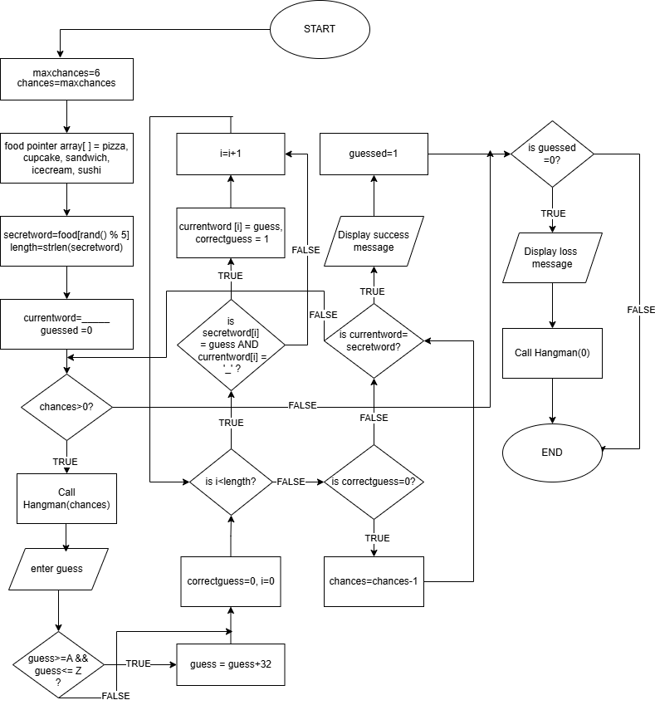
FLOWCHART

SOURCE CODE

#include <stdio.h> // printf(), scanf()
#include <stdlib.h> // rand(),srand()
#include <time.h> // time()
#include <string.h> // strlen(),strcpy(),strcmp()

void Hangman(int chances); // function declaration
int main( ) // execution starts here
{
printf("\n\t\t\t\t\tWelcome to the Hangman Game!\n\n");
const int maxchances = 6;
printf("Guess the secret food word!”);
printf("You only have %d chances!\n”, maxchances);

char *food[]={"pizza", "cupcake", "sandwich", "icecream", "sushi"};
// food is a pointer array
srand(time(NULL)); // seed random number generator
char secretword[30];
strcpy(secretword, food[rand() % 5]);//copy word to secretword
int chances = maxchances;
int length = strlen(secretword);
char currentword[30];
int i;

for (i = 0; i < length; i++)
{
currentword[i] = '_'; // fill currentword with underscores
}
currentword[length] = '\0'; // add null character at the end
char guess;
int guessed = 0;

while (chances > 0) // iterate until user has chances to guess
{
printf("\nWord: %s\n", currentword);
Hangman(chances); // function call
printf("\nEnter a letter: ");
scanf(" %c", &guess); // saves input letter in guess
if (guess >= 'A' && guess <= 'Z')
{
guess = guess + 32; // convert uppercase to lowercase
}
int correctguess = 0;
for (i = 0; i < length; i++) // check if guess is correct
{
if (secretword[i] == guess && currentword[i] == '_')
{
currentword[i] = guess;
correctguess = 1; // flag indicates guess was correct
}
}
if (correctguess == 0) // if guess is wrong
{
chances--; // decrease chances
printf("Wrong guess! Chances left: %d\n", chances);
}
else
{
printf("Correct guess!\n");
}
if(strcmp(currentword, secretword)==0)//check if guessed
{
printf("\nYou guessed it! The word is: %s\n", secretword);
guessed = 1; // indicates word guessed
break; // exit loop
}
}

if (guessed == 0) // if chances = 0 and word not guessed
{
printf("\nGAME OVER!The word was: %s\n",secretword);
Hangman(0); // complete hangman
}
return 0;
}

void Hangman(int chancesleft)
{
switch (chancesleft)
{
case 6:
printf(" _______\n");
printf(" | |\n");
printf(" | |\n");
printf(" | \n");
printf(" | \n");
printf(" | \n");
printf(" | \n");
break;
case 5:
printf(" _______\n");
printf(" | |\n");
printf(" | |\n");
printf(" | O\n");
printf(" | \n");
printf(" | \n");
printf(" | \n");
break;

case 4:
printf(" _______\n");
printf(" | |\n");
printf(" | |\n");
printf(" | O\n");
printf(" | |\n");
printf(" | \n");
printf(" | \n");
break;
case 3:
printf(" _______\n");
printf(" | |\n");
printf(" | |\n");
printf(" | O\n");
printf(" | /|\n");
printf(" | \n");
printf(" | \n");
break;

case 2:
printf(" _______\n");
printf(" | |\n");
printf(" | |\n");
printf(" | O\n");
printf(" | /|\\\n");
printf(" | \n");
printf(" | \n");
break;
case 1:
printf(" _______\n");
printf(" | |\n");
printf(" | |\n");
printf(" | O\n");
printf(" | /|\\\n");
printf(" | / \n");
printf(" | \n");
break;
case 0:
printf(" _______\n");
printf(" | |\n");
printf(" | |\n");
printf(" | O\n");
printf(" | /|\\\n");
printf(" | / \\\n");
printf(" | \n");
break;
}
}

TECHNICAL TERMS AND CONCEPTS:
This section explains the key technical terms and programming concepts used in the Hangman game implementation. These elements form the core of the code and illustrate essential aspects of C programming.
- ARRAYS AND POINTERS: Arrays are used to store the list of possible secret words. char *food[ ] = {"pizza", "cupcake", "sandwich", "icecream", "sushi"}; ) is an array of string pointers, where each element points to a constant string literal stored in memory. Pointers enable efficient memory access and manipulation, allowing random selection via indexing.
- STRINGS AND STRING OPERATIONS: Strings in C are null-terminated character arrays. Functions from <string.h> like strcpy() (to copy the secret word) and strcmp() (to compare the guessed word with the secret one) are crucial in this code. The currentword array tracks the partially revealed word, initialized with underscores ('_') to represent unknown letters. String length is determined using strlen() to iterate the loops appropriately.
- RANDOM NUMBER GENERATION: To ensure unpredictability, the code uses srand(time(NULL)) from <stdlib.h> and <time.h> to seed the random number generator with the current time. This prevents the same sequence of random numbers each time the program is run. The rand() % 5 expression selects a random index from the word array, introducing variability in gameplay.
- LOOPS AND CONDITIONAL STATEMENTS: A while loop controls the main game cycle, continuing as long as chances remain. Nested for loops handle word initialization and letter checking. Conditional structures like if and switch manage guess validation (e.g., converting uppercase to lowercase manually), correct/incorrect feedback, and hangman drawing based on remaining chances.
- FUNCTIONS AND MODULARITY: The code uses a modular approach with a main( ) function for overall execution and a separate user defined Hangman(int chances) function to draw the hangman figure. This separation promotes code reusability and organization. Function parameters allow dynamic behavior, while the switch statement in Hangman() handles different visual states.
- INPUT/OUTPUT HANDLING: Standard I/O functions from <stdio.h> such as printf( ) for displaying output and scanf( ) for reading input are used. The format scanf(" %c", &guess); includes a space to handle whitespace, ensuring reliable character input. Each case in the Hangman function uses multiple printf( ) calls to build the hangman figure progressively.
- FLAGS AND VARIABLES: Flags (e.g., int correctguess = 0; and int guessed = 0;) track states like whether a guess was accurate or if the word is fully revealed. Constants like const int maxchances = 6; enhance readability and ease modifications.
These concepts highlight C's procedural nature, emphasizing control flow, data structures, and library usage to build reliable and efficient systems.
Many beginners struggle to understand loops, arrays, and string handling in C. This project provides a fun and interactive way to apply these programming concepts in a practical game.
CONCLUSION
Through our Hangman Game project, we delivered a reliable, varied, and stable game that works perfectly every time. The use of clean structure, error-preventing techniques, and control shows real programming strength. The development of this project greatly improved our understanding of arrays, loops, conditional statements, and functions teaching us how to break down a problem into smaller steps and implement them efficiently and prepared us for tougher challenges ahead.

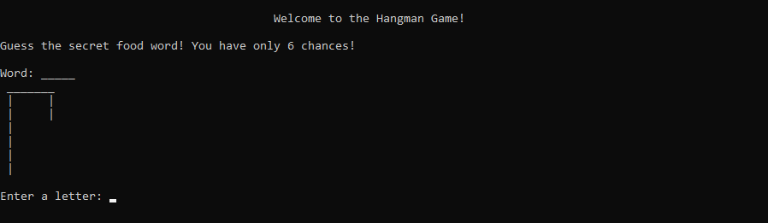
EXAMPLE RUN: PLAYER WINS!
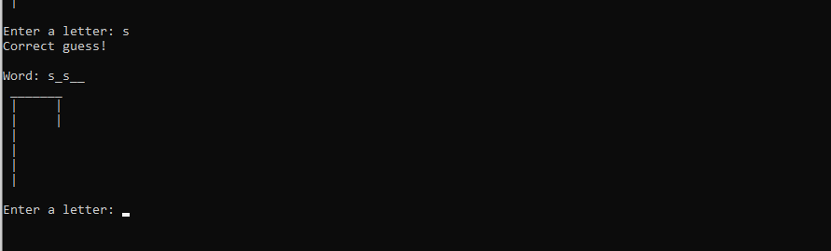
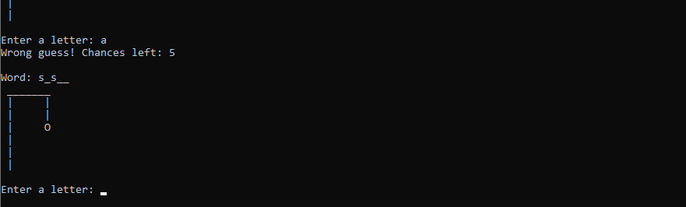
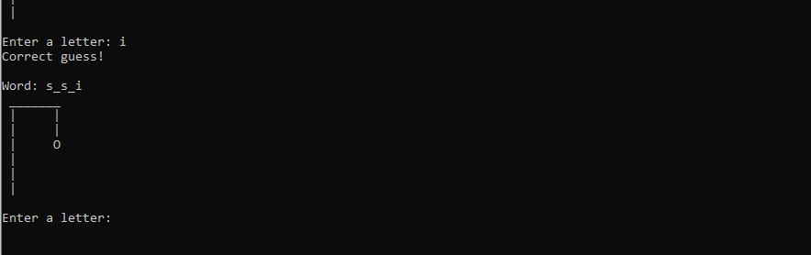

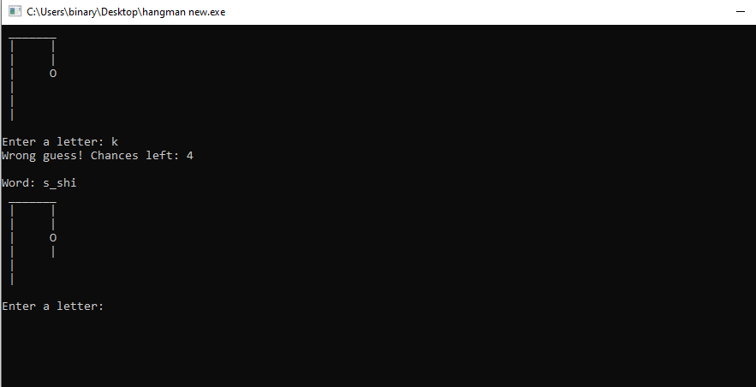
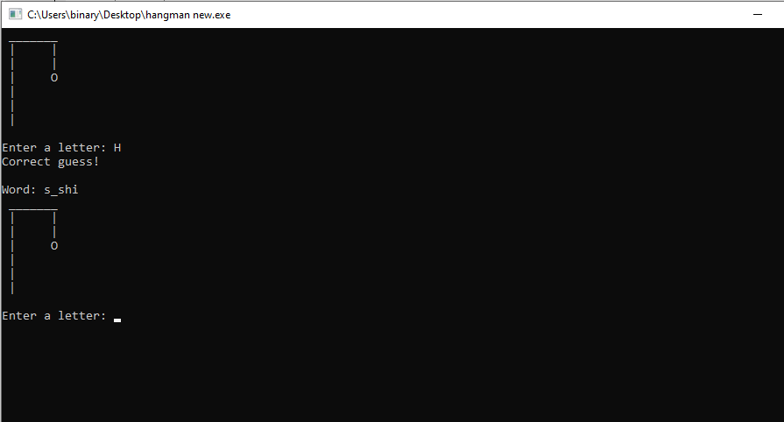
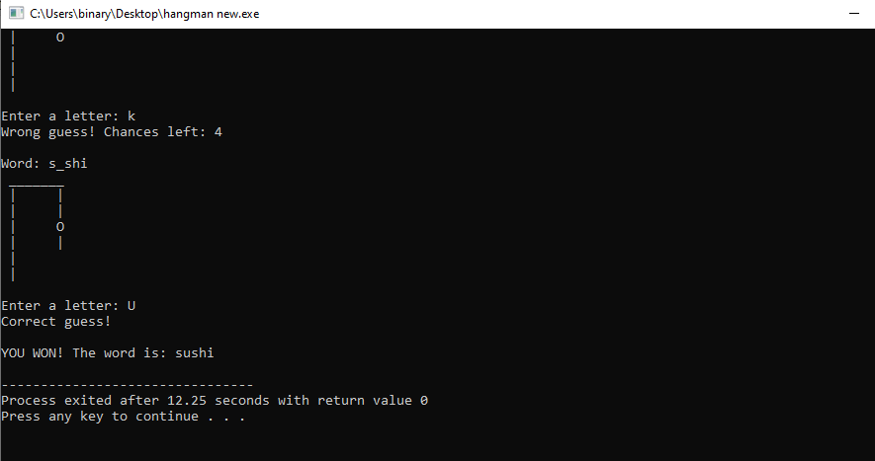

EXAMPLE RUN: PLAYER LOSES!
